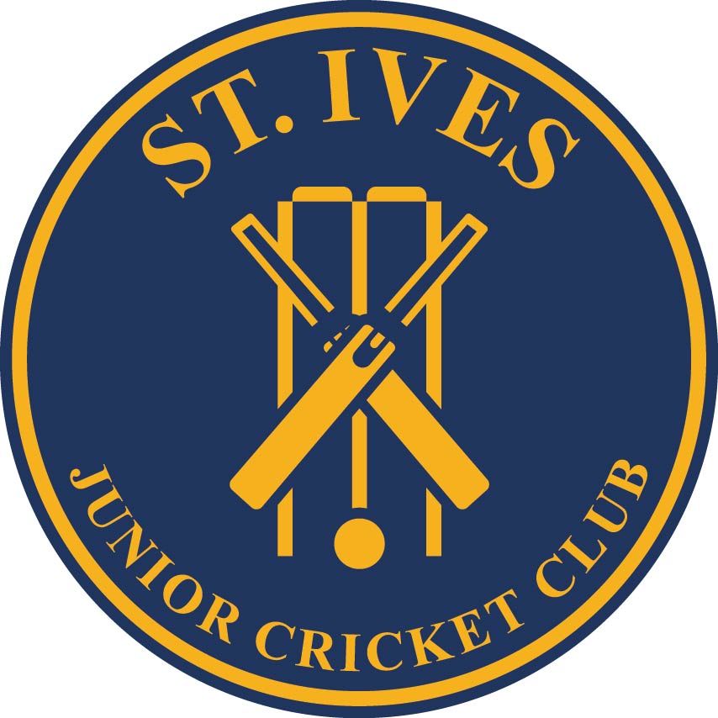

Parent/Guardian’s Consent Agreement

I agree to my son/daughter playing cricket with St. Ives District Junior Cricket Club. I acknowledge in accordance with the Club’s constitution his/her membership extends to my spouse/partner and me. As members we agree to be bound by the rules of the Club. I note that the Club will undertake to exercise all reasonable care in the conduct of its activities but declines to accept responsibility for accidents occurring as a result of my child’s participation in such activities.

I agree to authorise that myself and/or my son/daughter’s likeness may be recorded/edited/reproduced/broadcast/published/disseminated/distributed via electronic and/or other form, to be shown in public via radio, television, newspaper, magazine, Internet or other means, to be used by St Ives District Junior Cricket Club Inc.

I acknowledge that I assign all rights, title and interest including copyright to St Ives District Junior Cricket Club Inc., and acknowledge that St Ives District Junior Cricket Club Inc. is not obliged to use the multi-media material if it so chooses.
I agree to allow the Club to hold and use my contact details for any legitimate and reasonable purpose in relation to the Club's activities, including supply to the North Shore Junior Cricket Association, Hornsby Ku-ring-gai & Hills District Cricket Association (HK&HDCA), Cricket NSW and Cricket Australia. I understand that my details will not be sold or otherwise used for commercial purposes without my prior consent.

